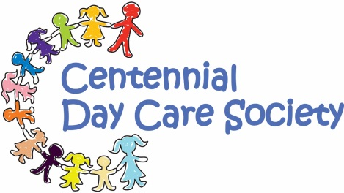
Yahoo! Sunshine! It has been so warm recently, and we think it’s safe to put away the thick winter jackets, but…our deck is cold until the sun comes around in the afternoon, so please pack lots of layers so we can be comfortable whatever the weather is doing, and can go on walks in the sunshine, or stay here!
Sunscreen. We would like to do away with having 20 different bottles of sunscreen to manage and store, so unless your child has severe sensitivities, we would like to suggest that parents donate a few dollars for us to purchase large bottles of Ombrelle for all the children. Ombrelle seems to be the brand that is the most hypo-allergenic, and safe for most. We understand if you have already purchased and brought in sunscreen.
NEWSLETTER Spring 2016
We also ask that you make sure to apply sunscreen in the morning, and we will reapply it in the afternoon.
Summer clothing With the good weather on its way sandals are welcome for outside play. Please keep in mind that sandals need to cover the toes, and be good for walking distances in. We cannot allow flip flop type sandals or crocs, as they are just not safe for running and climbing and the active play we get up to at day care.
Fundraisers We have a limited number of Serious Coffee cards left for sale. Each $15 card can be exchanged for a 400g bag of beans, or custom ground coffee of your choice.

Fri April 22nd is Earth Day,
We will be celebrating by doing lots of planting, and gardening in the afternoon. If you can join us to help out, and have some fun getting dirty we would love to see you! We plan to get going at around 3.00.
Other Dates to Remember
Hilltop plant delivery: Wed May 4th pm, and Thurs May 5th Mother’s Day: Sun May 8^{th.} Father’s Day: Sun June 19th.
We will be CLOSED
Victoria Day: Mon May 23rd
Canada Day: Fri July 1st
BC Day: Mon Aug 1st
14th Annual Walk-a-Thon fundraiser Fri June 24th at 9:30. Join us! This is such a fun event for everyone involved! We walk to Sumas Park, banner high, and enjoy special activities such as bubbles, face painting, temporary tattoos, picnic lunch and sports games on the grass. We really hope some family members can join us
GRAD/Summer potluck BBQ We are saying goodbye to friends who are leaving us for kindergarten, and will be celebrating this milestone with our annual family summer potluck BBQ and graduation ceremony. Join us on Fri July 15th from 4:00-5:30 for some tasty BBQ, conversation and socializing, and a small ceremony for our grads.
Please remember: We always accept your Canadian Tire money and put it to good use!

*We are always here to connect, and support, and will answer any questions or concerns.

from the Centennial Day Care staff.

