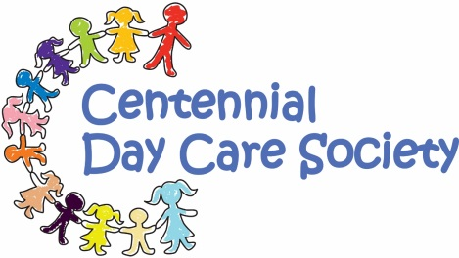
Welcome
Courtney Williams is with us for the summer, through the Canada Summer Jobs program, and we are very grateful to have her with us. This program supports students who are returning to school in the fall, in gaining valuable work experience in their chosen field. We are also sponsoring two ECE students from CDI college, who will be doing full day practicums here. Melanie is with us for 3 weeks, and then Julia will join us for 4 weeks. We consider it an important role for us to assist in the training of future ECEs. The children get exposed to some great activities, and we get to be updated on latest research or theories in ECE, along with the continued training we take throughout the year.
GRAD/Summer potluck BBQ
We are saying goodbye to friends who are leaving us for kindergarten. Motaz and Abdullah have already left for extended vacations, and before more leave us, we would like to celebrate this milestone with our annual family summer potluck BBQ and graduation ceremony. Join us on Thursday June 25th from 4:00-5:30 for some tasty BBQ, conversation and socializing.

NEWSLETTER: JUNE 2015
More info will follow including a potluck sign up sheet. We will provide the hamburgers, hotdogs, buns and condiments!
13th Annual Walk-a-Thon fundraiser
Monday July 20th at 9:30. Join us! This is such a fun event for everyone involved! We walk to Sumas Park banner high, and enjoy special activities such as bubbles, face painting, temporary tattoos, picnic lunch and a Sportball session on the grass. We really hope some family members can join us
Other fundraisers
Serious Coffee. We have a limited number of coffee cards available. Purchase a card for $15, and exchange the card at any store for a 400g bag of the coffee of your choice freshly ground to your specifications, or whole bean!
Canadian Tire $ We will accept your Canadian Tire money at any time and put it to really good use in the program!
Coffee Mondays
Starting Monday June 15th, we will have coffee and (possibly), baking available from 7:30-9:30am every Monday. Hopefully you’ll have a few extra minutes to tell us about your weekend, ask questions, give some feedback read a story with your child, or….? Bring your travel cup or use one of our mugs
Spontaneous Walks
As the weather improves (keep your fingers crossed), we will be going on neighbourhood walks to Sumas Park, the Selkirk Waterway, and other local parks and fun places. We leave for walks at 9:30am, so please have you child here prior to then as we cannot guarantee a staff member will be here if you arrive at the daycare after 9:30am, and we may not be back until 12.30 if we take a picnic lunch. *If you know you are going to be arriving after 9:30, please call us and we may be able to accommodate you, or arrange to meet you on route!

Staff holidays
Regular staff will be taking their holidays throughout June July and August. We are confident in the consistency of our program as only one staff member will be away at a time, and Courtney is here to cover the absences and provide continuity.
Bea…June 17,18 &19 and July 22,23 &24.
Brenda…….June 26-July 3 and Jul 27-31
Corissa…..Aug 4-14
Upcoming Closures
The daycare is CLOSED all STAT holidays.
Wed July 1st…………………Canada Day.
Mon Aug 3rd………………….B.C. Day
Mon Sept 7th………………..Labour Day

*Have a safe and Happy Summer, and if you have any questions…we are here for you and your family!!

